Usability Evaluation of Aertel (RTE’s teletext service) using Cooperative Evaluation - the Thinking Aloud Method

Module: Foundations in Interactive Media – CS6021

Lecturer: Dr Liam Bannon
Luigina Ciolfi

Students: Paul Adams - 9637281
Niall Cassidy - 0102016
Kieran Nolan - 0113867

Autumn Semester 2001/2002

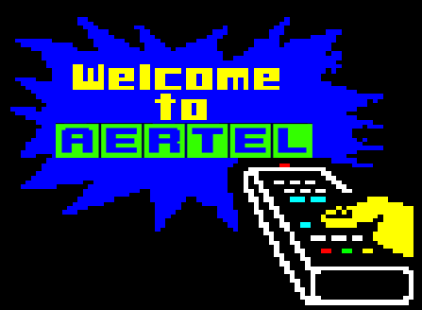

Table of Contents

01. Introduction

02. Reasons for choosing Aertel

03. The Thinking Aloud Method

04. Recruiting Users

05. Test Preparation

06. Task List

07. Pilot Test 7.1 - User No. 1

08. Results 8.1 - User No. 2
8.2 - User No. 3
8.3 - User No. 4
8.4 – Debriefing

09. Recommendations

10. Conclusions

11. References

12. Appendix 1: Aertel’s hierarchical structure

13. Appendix 2: Aertel screenshots

14. Appendix 3: Proposed structural solution

15. Appendix 4: Proposed graphical solution

16. Appendix 5: The future of teletext

1. Introduction

The aim of this study is to evaluate the usability of the teletext service provided by Ireland’s national broadcaster RTE. The name of the service is Aertel.

We would like to start by giving a brief description of what Aertel is and the services it provides. Aertel consists of pages of information on a large number of topics; ranging from latest news to bus timetables to stock market prices to subtitles; which are viewed on a television set capable of viewing these pages. At present the number of teletext capable television sets in Ireland is over half a million. Aertel is available 24 hours a day in many places and 7 days a week. It is also available online within RTE’s website but for the purpose of this evaluation we are going to concentrate on the ‘traditional’ method of viewing Aertel, i.e. on a television set. RTE have also developed Aertel Interactive, which will also be tested in this study.

2. Reasons for choosing Aertel

People may be surprised at our decision to evaluate an old service such as Aertel in the current age of tremendous technological advances. ‘Nobody reads Aertel, it looks awful’ some might say. And to a large extent that is true. Also, the computer press often slate teletext services, branding them defunct because of their looks (http://teletext.mb21.co.uk/faq.shtml). But this is exactly why we chose to evaluate such a service. It is as popular as ever despite the fact that it has remained largely unchanged since its conception in the late 1970’s. We felt this could be put down to excellent usability factors associated with Aertel especially with regard to ease of use and ease of accessibility. The aim of this study was to discover if we were correct!

3. The Thinking Aloud Method

The thinking aloud method is an extremely valuable but cheap usability engineering method for obtaining a lot of qualitative data about an existing system, a new prototype or even a rough mock-up. As the name suggests, the user should think aloud while performing set tasks on the product/service in question. By recording the users vocalised thoughts, we can further evaluate these thoughts after the testing session when the user has finished. This method makes it easy for us to understand the users misconceptions with the product/service. “One gets a very direct understanding of what parts of the dialogue cause the most problems, because the thinking-aloud method shows how users interpret each individual interface item.” (Nielsen, 1993, P195/196)

While it is possible to carry out an evaluation with this method by one sole researcher, it is more effective with two to three researchers. The team that carried out this study consisted of three researchers. Kieran Nolan recorded the test sessions with a Sony Handicam camcorder, Niall Cassidy took notes on occurring events while Paul Adams spoke with the user during recording and encouraged the user to think aloud. The role of Paul Adams (interviewer) in the Thinking Aloud method is essential, as the user often needs prompting and reminding to verbalise their thoughts. This can be done quite casually with questions such as, ”What are you thinking now?” A secondary role for the interviewer is to provide help when necessary. It is imperative to work out a policy for prompting and helping that avoids distorting the users natural thoughts. This is explained in more detail under the ‘Task List’ heading.

The main advantages of the Thinking Aloud method are that it is cheap and it gives excellent qualitative data (and as a result only 2-5 users are required). The main disadvantage is the inherent nature in which it is carried out “These results, however, may also give a false impression with respect to the usability problems when too much weight is given to the user's own "theories" of possible shortcoming and solutions. Another problem with talk-aloud is that thinking out loud is awkward for most people, and some participants have great difficulty in keeping up a steady stream of utterances as they use a system. Furthermore, this awkwardness makes the test harder to conduct and has a significant impact on the results for two reasons. First, the extra task of verbalization can slow users down, resulting in a less representative user working speed. Second, the actual verbalization of thoughts by the user can influence the users problem solving behaviour. The users begin to pay greater attention to inconsistencies in their view of the system and more critical task components. These changes may cause the user to learn the system faster or differently than if silent.”
(www.cc.gatech.edu/classes/cs6751_97_winter/Topics/observe-users/)

4. Recruiting Users

Aertel is intended for use by a large majority of the population and this is reflected by its wide diversity in content. As a result our potential users could be almost anyone with perhaps the exception of people with severe visual disabilities or people with a low level of literacy. Hence the age/sex breakdown of our users was of minimal importance. Of our four users, two had a little knowledge of the system, one had no knowledge of the system (aside from the fact that it existed), and one had a little knowledge of a similar system in his native country (Spain) but not specifically with Aertel. With regard to the latter, we thought it interesting to analysis how a user where English is not their mother tongue might interpret the system, especially as the system is often used in Irish hotels by foreign nationals to find out about Irish services such as bus/rail timetables etc.

As experienced users of the system, we felt that its ‘beauty’ lay in its ease of use and it was an excellent example for the theory that ‘less is more’ in interface design. What we could not comment on is the systems learnability* as it is many years since we learned how to use the system. This is why the focus with our users is on the inexperienced user.

*Learnability – “This is a measure of how easy the system is to learn so the users can start to use some of the functionality provided. This is important as learning to use the system may be the first experience an unknowledgeable user has with it.”
(http://www.ul.ie/~cscw/intnotes/evaluation/car/car.html)

5. Test Preparation

Before the users arrived it was important to make sure that items such as the video camera were working properly and that all the necessary items needed were at hand, i.e. writing pad to take notes etc. It was also imperative to make sure that all tasks could be completed on the test days in question. To verify this, we went through the tasks ourselves beforehand.

As stated earlier, it is crucial to the success of the thinking aloud method that the users are at ease in the testing environment. We were conscious of their possible apprehension regarding the use of the video camera and the possibility that they may feel that it was them being tested and not the Aertel service. It was important to clarify a few things early on to prevent them being uncomfortable. First of all the user was introduced informally to the three researchers and thanked for agreeing to participate in the study. The purpose of the study was then explained to them and a brief explanation of the thinking aloud method was given with particular emphasis on why the video camera was needed. It was then explained that it was the Aertel system that we were evaluating and not the user. We explained that if they were unable to or had difficulty with completing a task, it was because the design of the system had failed them through no fault of their own and that the goal of the study was to make recommendations to correct these design errors in the future.

We did not hand the user a task sheet as we felt that it would be reminiscent of an exam situation. Instead, the tasks were communicated verbally to encourage more dialogue and to increase the user’s feeling of relaxation. It must be pointed out though that the tasks were read by the interviewer directly from his own task sheet (outlined below) and were communicated exactly as they appear below. No other help or direction was communicated unless the user encountered a problem with the task at which point the interviewer gave them an interim task from the back up task list.

6. Task List

We have separated our task list into two areas: mechanical tasks and tasks involving information retrieval. Mechanical tasks involve using the interface on the remote control to access Aertel or to make changes to its appearance. *See ‘note on the television remote control’ under the task list. Information retrieval tasks involve navigating the on screen interface. The mechanical tasks were carried out first followed by the information retrieval tasks. This was the most logical sequence for the tasks as they get progressively more complicated. Should the user have trouble with early information retrieval tasks we have included 2 easier back up tasks to help them complete problematic tasks.

We chose tasks which would be common in the everyday usage of Aertel. Items such as news, weather, entertainment listings and travel information would be of interest to the general public.

Mechanical tasks:
- Turn on Aertel
- Make the text larger
- Make the Aertel text transparent so that you can see the television image in the background

Information retrieval tasks:
- Use Aertel to find out the latest news on the war in Afghanistan
- Use Aertel to find out about today’s weather
- It is possible to use Aertel to turn on subtitles for the currently showing television program. Turn them on.
- You want to go and see a film in the Savoy cinema in Dublin’s city centre on Sunday evening next. Use Aertel to find out what is currently showing and if it has received good reviews.
- You want to go from Dublin to Limerick by train tonight. Use Aertel to find out what times the trains are running.

Back up tasks:
- Find the contents index
- Find out if there is weather link in the contents index.

*Note on the television remote control: Aertel is accessed through the television’s remote control. The teletext button interface and available options varies between television manufacturers and also between television models. This is a problem with regard to the usability of Aertel as interfaces in different environments are not consistent. However, this study is an evaluation of the usability of the Aertel service as it is presented on screen and not of the individual remote controls and hence these inconsistency problems will not be covered within this study.

7. Pilot Test

Our interview setup between the pilot test and the main interviews did not change radically. We stayed to our team of 3, one cameraman, an interview and an additional person taking written notes of the proceedings. The venue of Paul’s apartment remained throughout as did the same Philips brand teletext enabled television. The method in which we recorded the information through the Mini DV camera did change however.

Originally we attempted to capture other information apart from the television screen, such as the remote control being used and footage of the interviewer and user discussing the product with the television in the background. After this test we decided that it would be less distracting when the recordings were been transcribed to have the camera fixed in a stationary position, focusing on just the screen. This would also allow maximum legibility of the recorded teletext display.

When viewed through a digital camera the screen image flickers due to how the screen appears and the colours appear distorted. This is virtually undetectable to the human eye but obvious to the point of distraction when viewed through a video camera.

In conclusion it was agreed that once the dialogue and accompanying screen changes were recorded with the addition of hand written commentary on the user’s non-verbal (facial expressions etc) responses, the questions were more than adequate and appropriately phrased.

7.1 – User No. 1
Name: Cormac
Level: ‘a little knowledge of the system’

Task 1: Turn on Aertel
Cormac had no problem turning on Aertel. He recognised the correct button on the remote control from its icon. (See Appendix 2 – Image 1)

Task 2: Make the text larger
Cormac quickly completed the task by selecting the correct button on the remote control.
“I just checked the buttons and chose the button because of the symbol, there’s a little picture of the screen split in half and there are letters in front of it”. (Appendix 2 – Image 13)

Task 3: Make the Aertel text transparent so that you can see the television image in the background
Cormac completed this task without any problems. On inspection of the remote control he choose the correct button first time based on its icon. (See Appendix 2 – Image 12)

Task 4: Use Aertel to find out the latest news on the war in Afghanistan
Cormac used fastext to access ‘headlines’: “The green button on the end said Headlines”. Cormac was referring to the fastext index at the very bottom of the page where pages are differentiated and referred to by colour code that correspond to the coloured buttons on the remote control. (See Appendix 2 – Image 1) This brought up page102-Headlines. This page showed three news headlines none of which had a relevant story pertaining to the task: “It doesn’t actually seem to say anything about Afghanistan there so I suppose I’ll try ‘next’, maybe that will bring me to the next news page”. (See Appendix 2 – Image 4) He then pressed the red fastext button for next: “There it is, emmm, where’s the latest news on Afghanistan”. He then scanned the list of news stories: “I don’t know, its pretty hard to read that the way that its all scrunched up together!” He had trouble reading the text but eventually found a relevant news story and keyed in page 113 to get to the story and successfully complete the task. (See Appendix 2 – Image 5)

Task 5: Use Aertel to find out about today’s weather
When told the next task Cormac noticed a fastext link for the weather on the page he was currently on -113 from the last task. (See Appendix 2 – Image 5) He followed this link and was taken directly to today’s weather. Task completed. Paul then asked Cormac to return to the home page and see if he could find his way to today’s weather from there. Cormac keyed in page 100 manually arriving at the Aertel homepage. He then chose to go on to the full index via the Fastext link. Following on from this he scanned the page and found a Fastext link to ‘weather’. He finally followed that and found today’s weather page number in the index, keyed in page 161 and successfully completed the task.

Task 6: It is possible to use Aertel to turn on subtitles for the currently showing television program. Turn them on.
Cormac keyed in 888 and went directly to the subtitles page: “I knew it was 888, just remembered, don’t know why”. Paul asked him to try and get there from the homepage. Cormac went to the homepage, then the full index, saw and selected the subtitles page link 888. Task successfully completed.

Task 7: You want to go and see a film in the Savoy cinema in Dublin’s city centre on Sunday evening next. Use Aertel to find out what is currently showing and if it has received good reviews.
Cormac manually keyed in page 100 to return to the homepage. He then used Fastext to go to the ‘full index’, (see Appendix 2 – Image 2) scanned the screen and found the cinema link (page 310) and manually keyed this number in. On the cinema index page (see Appendix 2 – Image 8) he immediately found the Dublin city centre page (311) and manually keyed in the number. This page was a rotating page with the various city centre cinemas on different pages numbered 1 to 5. On this occasion the rotating page opened up with the Savoy cinema completing the first part of this task. (See Appendix 2 – Image 9)

On the second part of the task Cormac was unsure as to whether Aertel contained cinema reviews: “Do you know if there are reviews on Aertel?” He then couldn’t remember how to get back to the cinema index: “I cant remember the cinema index page number” but then as the current page rotated to page 3 of 5 a banner appeared at the bottom of the screen with the page number for the cinema index. He keyed in 310 manually and on getting to the page immediately located the ‘reviews’ link at the bottom of the index and manually keyed in 345 to go to the reviews. “I want to check out “Glitter”, the new Mariah Carey movie”. On the reviews page he scanned the list (See Appendix 2 – Image 10) and manually keyed in 346 to go to the ‘new cinema releases’ reviews page. A new rotating page came up with the 3 new releases each on an individual page. ‘Glitter’ came up in turn to successfully complete the task. Note: Cormac didn’t seem to know that you could freeze each individual page with the remote control.

Task 8: You want to go from Dublin to Limerick by train tonight. Use Aertel to find out what times the trains are running.
Cormac went back to the homepage and using Fastext went to the full index. He couldn’t find any information on trains in the full index and got a bit confused: ”Did you say ‘train’, that’s weird…do you know if there definitely is a page?…..I’m going to go to the Bus Eireann page because there might be a link there”. He then keyed in 550 to get to the Bus Eireann page. Cormac found no information on trains so he went back to the homepage where he noticed a link to ‘travelfinders’ on page 500. But again no joy: “travel timetables, sea ferry timetables – it doesn’t really seem to have trains”. He then followed the ‘travel timetables’ link page 549: “Oh there’s the train timetables, that’s ridiculous the way it was so hard to find that “. He then keyed in 777 to access the timetables. The Aertel interactive page came up: “Oh it’s interactive!” (See Appendix 2 – Image 19) On the page itself the words ‘Down For Updating‘ were flashing at the bottom of the screen and Cormac was confused as to what to do. He rang the number anyway to complete the task.

8. Results

8.1 - User No. 2
Name: Alan
Level: ‘a little knowledge of the system’

Task 1: Turn on Aertel
Alan had no problem turning on Aertel. He recognised the correct button on the remote control from its icon. “I’m going to press this button here, it has lines on it like text”
(See Appendix 2 – Image 1)

Task 2: Make the text larger
Alan completed this task without any problems. On inspection of the remote control he choose the correct button first time based on its icon. (See Appendix 2 – Image 13)

Task 3: Make the Aertel text transparent so that you can see the television image in the background
Alan completed this task without any problems. On inspection of the remote control he choose the correct button first time based on its icon. During debriefing Alan commented that both tasks two and three were “educated guesses”. He said that he might have been a bit lucky and had he chosen the wrong button he would have pressed them all until he found the correct one.
(See Appendix 2 – Image 12)

Task 4: Use Aertel to find out the latest news on the war in Afghanistan
Alan did not know where he might be able to read the news. However he immediately noticed on the home page that it said ‘Full Index 101’: “I’m going to 101 because it says full index”. When the full index came up (See Appendix 2- Image 2) he quickly saw that news was located on page 102: “I’m going to 102 because it says news”. He manually keyed in 102 and when the page was displayed there were only 3 headlines, one of which (on page 118) had a reference to the war in Afghanistan (See Appendix 2 - Image 4). He also noticed a fastext link that said ‘headlines’. “There’s headlines there too, don’t know if there’s more information there”. He used fastext to go to the other headlines page from where he found all the latest news on Afghanistan. (See Appendix 2 – Image 5)

Task 5: Use Aertel to find out about today’s weather
Alan’s first problem with this task was the fact that he was now on a news page (page 118) and did not know how to get back to the homepage: “I’m not too sure how to get back to the homepage but it’s usually page 100 or 101”. His aim was to try and navigate his way to the weather page from the homepage. He keyed in 100. He went straight to the full index using the red fastext link: “Going to hit the red button straight away for full index”. From the full index he quickly commented that weather was on page 160 so he keyed in page 160. On page 160 he immediately noticed that the current day’s weather was on page 161 so he keyed in page 161 and read the weather report contained within.

Task 6: It is possible to use Aertel to turn on subtitles for the currently showing television program. Turn them on.
Alan’s first response to this task was surprise: “I can try, I didn’t know you could do that”. Again his first intended action was to return to the full index. A fastext link at the bottom of the screen read ‘index’. However this link took Alan back to the weather index and not the full index as he had presumed. So he then typed in 100 to take him back to the homepage. He then pressed fastext to go to the full index. He quickly noticed that Subtitles are contained on page 888 and so keyed in 888 to complete the task.

Task 7: You want to go and see a film in the Savoy cinema in Dublin’s city centre on Sunday evening next. Use Aertel to find out what is currently showing and if it has received good reviews.
Again Alan’s first action was to go back to page 100 and from there to the full index: “I’m going to go to the full index again”. He noticed two potentially relevant categories, ‘entertainment’ and ‘cinema’. “There’s entertainment 300 and cinema 310 so I’ll try 310 first”. He keyed in 310 and noticed that the cinema listings for Dublin city centre were located on page 311 (See Appendix 2 – Images 8 + 9) so he keyed in 311. At this stage the task became problematic for Alan. He was looking for the listings for the Savoy cinema but when page 311 was displayed it only had listings for the UGC cinema: “That’s not the one we’re looking for”. He pressed the red fastext link which read ‘next’ presuming it would take him to the next cinema in Dublin’s city centre. However, his action took him to page 312, which contained cinema listings for Dublin’s suburbs. In this page he notices that this is a scrolling page and he is currently on page 1 of 4: “It’s page 1 of 4 so possibly page 2, 3 or 4 might be it”. Only now (upon reading ‘Bray’ at the top of the screen) does he realise that he is looking at the listings for the suburbs: “Now I’m in the suburbs….”. He is unsure exactly what he has done and how he can get back to the city centre listings: “I’m just going to go back to 100, because I don’t know how to get back from here”. When the homepage comes up he goes to the full index and again to the cinema page on 310: “Going to try 310 again in case I missed something”. He then goes into 311 again. He now realises that 311 is also a scrolling page: “I didn’t see that the first time around, there’s a number of pages here as well”. He then waits for the page to scroll on until the Savoy cinema comes up and he completes the first part of the task.

He now needed to find out what has been recommended by others so he starts to look for a reviews page. His first action is to go to the ‘entertainment’ section he found earlier: “I’m just going to go to entertainment there, there might be something on it”. He goes to entertainment (See Appendix 2 – Image 7) but does not find anything of relevance. He then goes to the cinema index but again cannot find anything of relevance so he goes back to the homepage. At this point he makes a comment on his slight frustration in trying to complete the task: “I’m just going to go back to 100…. it feels like I’m going around in circles”. Alan now decides that the reviews must be under either ‘entertainment’ or ‘cinema’. He goes back to 300 and reads the whole page but finds nothing. He is quite lost at this stage and decides that all he can is hit the ‘next’ fastext button: “I’m just going to hit next”. He goes to 301 and after reading 301 hits next to go to 302, both of which are highly irrelevant. At this point Paul had to intervene as he had given up on finding anything. Paul suggested going back to the cinema index and looking again. He does and notices that at the very bottom it says that reviews are on page 345: “Oh yeah, there’s reviews, I didn’t see that”. (See Appendix 2 – Image 8) He goes to 345 and then goes to page 347 as it told him on 345 that 347 contained a review round up. Just as 347 comes up he noticed something else on page 345 but now couldn’t go back to see what it said in full: “Oh, there was something else there….if I could go back I would”. He completes the task but the final dialogue illustrates an interesting and common complaint: the fact that the Aertel system does not allow for one to go back to the immediately previous page.

Task 8: You want to go from Dublin to Limerick by train tonight. Use Aertel to find out what times the trains are running.
Alan keyed in 100 to go to the homepage and then used Fastext to take him to the full index. “I can see Bus Eireann - I don’t know if there’s a separate category or not for Iarnrod Eireann, it’s not on this page anyway. I’m going to try Bus Eireann even though I don’t really expect to find it there.” Alan keyed in 550 to go to the Bus Eireann page. As he had expected, Alan did not find any link to the Iarnrod Eireann page. “No, I don’t think I’m going to find it here at all. I’ll go back again”. Alan manually keyed in page 101 to go to the full index page. “I’m just going to try A to Z on page 595. I only just realized there was an A to Z”. He then keyed in 595 and arrived at the A to Z rotating page (See Appendix 2 – Image 18): “There’s 9 pages so all I can do at this stage really is just leave it scroll through. I can’t control it……..it probably offers me a better chance than what I’ve seen already”.
He then went on to say: “I’m looking for Iarnrod Eireann or else if train timetables schedules are on it…………..I’d expect if it was here they have it in the A-Z index………..there’s probably an easier way of doing this but at this stage I haven’t come across it, so this is the last resort really.” Familiarity with the operation of the Internet and technology’s advances soon became apparent: “It would be useful if you could actually forward the pages”. Alan waited for the pages to scroll through until he found Iarnrod Eireann under ‘I’. Alan then keyed in 777 and the Iarnrod Eireann interactive page appears (See Appendix 2 – Image 19) where only a phone number is displayed: “That’s it, at this stage I would take it there is no schedule and that you just have to dial that number”.

8.2 - User No. 3
Name: Guzman
Level: ‘no knowledge of the system’

Task 1: Turn on Aertel
Guzman had no problem turning on Aertel. He recognised the correct button on the remote control from its icon: “First, press this button”. (See Appendix 2 – Image 1)

Task 2: Make the text larger
Guzman completed this task without any problems. On inspection of the remote control he choose the correct button first time based on its icon. (See Appendix 2 – Image 13)

Task 3: Make the Aertel text transparent so that you can see the television image in the background
Guzman completed this task without any problems. On inspection of the remote control he choose the correct button first time based on its icon. (See Appendix 2 – Image 12)

Task 4: Use Aertel to find out the latest news on the war in Afghanistan
Guzman quickly noticed on the Aertel homepage that it said ‘Full Index 101’ so he manually selected page 101. In the full index (See Appendix 2 – Image2) he noticed that news was on page 102: “OK, now I choose 102” and from 102 went to page 117: “Em, reports on Bin Ladens whereabouts, I choose 117”. The fourth task was completed with no difficulty.

Task 5: Use Aertel to find out about today’s weather
From page 117 Guzman keyed in 100 to go back to the homepage. He then decided to go to the full index for more information: ”Now it will be page 101 for contents”. He then saw that weather was on page 160 and keyed in 160. On page 160 he immediately saw that ‘today’s forecast’ was on page 161 and keyed in 161 to complete the task.

Task 6: It is possible to use Aertel to turn on subtitles for the currently showing television program. Turn them on.
Guzman completed task six very quickly. From page 161 he went back to the homepage, then to the full index, read that subtitles were on page 888 and keyed in 888 to complete the task.

Task 7: You want to go and see a film in the Savoy cinema in Dublin’s city centre on Sunday evening next. Use Aertel to find out what is currently showing and if it has received good reviews.
Once again Guzman went straight to the full index. He quickly found that the cinema index was on page 310: “OK so that’s the full index……and then cinema I suppose”. He read the full page before checking with us that it was the city centre he was looking for. From page 310 he went to page 311 which was said to be (on 310: See Appendix 2 – Image 8) Dublin city centre listings. Page 311 came up with listings for the UGC cinema in Dublin. This is a multi-layer page but Guzman did not realise this: “So, I don’t know how to go back”. He then remembered that he had been on page 310 so he keyed in 310 and returned to the cinema index. He now became quite confused: “It is in city centre so it is supposed to be in 311?” He went back into 311. Again it comes up with UGC listings. His confusion is compounded: “This is the cinema in Dublin city centre…there is no more”. He once again goes back to 310. Guzman did not realise that page 311 (see appendix 2 – image 9) was a multi layer page and had run out of ideas. I had to intervene and help him by explaining the concept of multi-layer pages. He was still slightly confused: “I don’t understand….it changed but I thought it was the same cinema….I didn’t know it was different cinemas”. A problem here was language, as Guzman did not know the names of the cinemas in Dublin. This issue will be dealt with in the recommendations section of this report.

Guzman had little problem completing the second part of the task, to read reviews on the currently showing films. He went back into the cinema listings and figured that this was where he might find further information: “There is nothing there to tell you about the plot….just the title”. So he went back to the cinema index on page 310. He reads the full page, sees ‘reviews’ at the bottom and keys in the appropriate number to complete the task. (see appendix 2 – image 8)

Task 8: You want to go from Dublin to Limerick by train tonight. Use Aertel to find out what times the trains are running.
Guzman’s first action of this task was to go back to the full index. On reading the page in depth (see appendix 2 – image 2) he concluded that ‘Stena Line’ must be for trains. This was because of the interface layout. In the index, ‘Bus Eireann’ lay above ‘airports’, under ‘airports’ was ‘Stena Line’ and under ‘Stena Line’ was ‘Irish Ferries’. Guzman thought that this represented buses, air travel, trains and boats respectively: “I suppose that this is because here is bus, here is airports and here is ferries, so Stena Line is for trains”. So he goes to ‘Stena Line’ on page 581 only to discover that it is an advertisement for holidays to Britain with the Stena Line ferry company. He goes back to 101 again, rereads it and quips: “So there are no trains in Ireland”. Rather amusing at the time but this is the perception of how Aertel presents it’s travel information. Guzman did not know what to do so we prompted him by asking him if there was anything on that page which might be able to help him find information on trains. Again language proved to be a barrier: “I don’t know Eireann, is that just a bus?”. Eventually he sees the reference to an A-Z index and follows the link. The A-Z index page came up (see appendix 2 – image 2) under the letter ‘I’ and the first item was ‘Iarnrod Eireann’. Guzman did not comment here and let the page scroll to ‘T’ before noting that there was no reference to trains whatsoever. He could not complete the task. On debriefing he mentioned that he had never heard of ‘Iarnrod Eireann’ before.

8.3 - User No. 4
Name: Aoife
Level: ‘no knowledge of the system’
(Note: session not videoed – hand written notes taken)

Task 1: Turn on Aertel
Aoife had no problem turning on Aertel. She recognised the correct button on the remote control from its icon: “The lines look like text”. (see appendix 2 – image 1)

Task 2: Make the text larger
Aoife completed this task without any problems. On detailed inspection of the remote control she choose the correct button first time based on its icon. She commented that it seemed to be the most logical choice. (see appendix 2 – image 13)

Task 3: Make the Aertel text transparent so that you can see the television image in the background
Aoife completed this task without many problems. On another detailed inspection of the remote control she choose the correct button first time based on its icon. Again she commented that it seemed to be the most logical choice. (see appendix 2 – image 12)

Task 4: Use Aertel to find out the latest news on the war in Afghanistan
On the homepage Aoife noticed that it said ‘latest news 102’ so she keyed in 102. This gave her three headlines (see appendix 2 – image 4), one of which (on page 117) was related to the war in Afghanistan. She keyed in 117 to read the story and completed the task. She remained unaware however, that further information was available on other news pages.

Task 5: Use Aertel to find out about today’s weather
Aoife did not have much difficulty completing this task. She remembered that the homepage was on page 100. She went from 117 back to the homepage, then to the full index and then to weather on page 160. From 160 she followed the link to page 161.

Task 6: It is possible to use Aertel to turn on subtitles for the currently showing television program. Turn them on.
Once again Aoife followed the same route to find the correct page. She went back to the homepage, then to the full index and then keyed in page 888 after reading the information in the full index.

Task 7: You want to go and see a film in the Savoy cinema in Dublin’s city centre on Sunday evening next. Use Aertel to find out what is currently showing and if it has received good reviews.
This task proved more challenging to Aoife than previous ones. Up until this point she was surprised with how easy the system was to learn and navigate and commented: “Everything seems to be in the full index so once you know where that is you can find what you’re looking for quite easily”. She started on the homepage and went to the full index (see appendix 2 – image 2) where she easily found cinema and keyed in 310 (see appendix 2 – image 9) to go to the cinema index. Here she keyed in 311 to go to the Dublin city centre listings. The page opened up on the Savoy so she did not encounter any problems with the page scrolling as previous users had. She then went about trying to find some reviews. She went back to the cinema index: “I remember that it was page 310 so if I key in 3-1-0 it should come up, I’m sure”. After reading page 310 carefully she found reviews on the bottom and keyed in 345 to go to reviews (see appendix 2 – image 10). From 345 she went to 347 to read the reviews (see appendix 2 – image 11) in brief and complete the task.

Task 8: You want to go from Dublin to Limerick by train tonight. Use Aertel to find out what times the trains are running.
Aoife started this task by going to the full index: “I remember this time that the full index is on page 101 so if type in 1-0-1 then it should come up, shouldn’t it?……..Ah, yes, there it is”. She read the whole page but failed to find any train information and ended up going to the A-Z: “That’s strange, I can’t find any train page….buses and ferries and airports but no trains……Oh, here is an A-Z, maybe it is in that”. When the A-Z (see appendix 2 – image 18) came up it was on the letter ‘E’. She was looking for some link to the next letter when the page changed and she realised that the pages were multi-layered and they changed over time: “Ah, so that’s how it works”. When it came around to ‘I’ she found Iarnrod Eireann was on page 777. On page 777 (see appendix 2 – image 19) she saw the phone number and completed the task.

8.4 – Debriefing

After the recording of the tasks we had a debriefing session with each user. We asked a series of questions to get feedback on their general perception of the system and how satisfied they were with using it. Their responses were very similar so we have grouped them together to avoid repetition.

What do you think is the best thing about the Aertel system?
Apart from the language barrier problems encountered by Guzman, the other users commended Aertel’s comprehensive and up to date information but also the ease at which it could be accessed. It was also mentioned that accessing teletext through a television set is a lot less daunting than setting up a connection to the internet. Also the fact that the service is free was a major factor: “…that its free, that its on your T.V. It’s handy and you don’t have to boot up a computer, its just there and its fairly accessible.”

Do you think it is easy to use?
It was found that despite the limited amount of buttons presented to the user that navigation of the teletext pages through the use of 3 digit number and the fastext keys worked well. “Yeah, its fairly easy to use. The control that you have is fairly limited, you don’t have a keyboard or mouse or anything, so its very good for what you have in your hand.”

What do you think is the worst thing about Aertel?
What annoyed the users most about the system is the wait involved for the ‘data carousel’ before the selected page is displayed. Also the automatic playing of a sequence of pages in a selected topic was another nuisance factor: “You don’t have any control over it”.
Also the Aertel Interactive feature was seen as: “a bit of a scam really… if they can cover bus schedules, which I’d imagine are a lot more complicated, they can surely cover train schedules”

How easy did you find the tasks?
The users all managed to get through most of the tasks, although some prompting was necessary for Guzman who was not familiar with the Irish language and came to a standstill when he could not find the train times because they were filed in the A to Z index under ‘Iarnrod Eireann’.

Did you find the recording equipment intrusive?
None of the users found the recording equipment to be a distraction when undertaking their tasks.

9. Recommendations

Aertel and similar teletext based systems are fighting to survive in their current format due to the digital revolution. Digital television is bringing with it digital teletext and the end of analogue television systems will see the end of analogue teletext. Digital teletext, although only new, is already fighting to survive with the Internet. This is dealt with in more detail in Appendix 5 in our essay titled ‘The future of teletext’. First though we must look at Aertel itself.

RTE have all but abandoned plans for a changeover to digital services in the foreseeable future. This would suggest that Aertel will exist in more or less its current format for at least another 10 years. During this time it will have to compete with digital teletext and the Internet. However, Aertel has an advantage over digital teletext systems. It is exclusively Irish. It is unlikely that English digital teletext systems will have information on Irish bus times or what is currently showing on TG4. Aertel could probably survive on this premise. However, we are suggesting an overhaul in the interface layout of the current Aertel system. It could be a much better service and although it has many advantages (it is free, readily available on your television set etc) its usability could be greatly improved.

Structure

Most of the faults in the Aertel system lie in the placement of information within its structure. It is continually inconsistent. The tested users found indexes contradicting indexes and items in places where they would not expect them to be. The system is hierarchical in nature with indexes and sub indexes and related information. This is understood to work by the 3 numbers system. The system is comparable to a 999-page book with chapters and topics within that chapter. If the Finance index is on page 130, then it is presumed that banking with AIB will be within the pages under 13X. However, banking with AIB is in fact on page 640. If we look at the index on page 600, we find ‘HOROSCOPES’ in big bold letters. This example illustrates Aertel’s biggest fault – very little natural mappings. Mapping problems are abundant within the system. For example, the sport index is on page 200. The football index is on 220 and the stories are (usually) within 220-229. This is an example of good mapping within the system and how it is relatively easy to organise coherently. However, if we are looking for the ‘latest Premiership football news’ we have to search in depth for it. It is on page 630. The only conclusion we could come to over its location is that a lazy designer just dumped it there.

In the cinema task all users had problems with the reviews part of the task. On the cinema page there is a link to reviews, ‘reviews 345’. On entering 345 users are confronted with a new index with contradicting titles: ‘New Cinema releases 346’, ‘Cinema Review round-up 347’ and ‘Movies still showing A-Z 348’. Also on this page is ‘Theatre 349’. First of all, what is the difference between pages 347 and 348? At the time of writing both pages contain a review on the ‘Harry Potter’ film. Is this not contradictory and a waste of space? Why separate film reviews nonsensically? This is only confusing for the user who only wants a quick review/run-down on the films showing in the cinema at the moment. Also on this page is the obscure reference to the theatre. In the entertainment index on page 300 we are told that Theatre is on page 330. Yet under ‘Cinema: Reviews’ we have references to play titles. This is highly inconsistent with the overall system and another example of bad mapping. A fastext link to the Theatre index would be far more appropriate.

The above example is a common problem throughout the system. The over all system structure is badly thought out. It seems like if a new topic has to be inserted, it is thrown wherever is handy at the time. Although an inherently hierarchical system, Aertel is not organised hierarchically.

Recommendation: We are recommending an overhaul in the way items are organised. We are recommending a proper hierarchical structure with good natural mappings. We are also trying to keep indexes at the same number as they previously were so that existing users are not alienated and to maximise the amount of information in the world and minimise the amount of information needed in the users’ head. (Norman, 1988, p54) Our proposed outline (see appendix 2) is by no means completely finished. It is merely a prototype guideline to how the system should be mapped.

Language

Some of the language used within Aertel is excluding in its nature. In many places Irish terms are used which may not be understood by foreign nationals or people unfamiliar with certain aspects of Irish life. This was highlighted during our tests with our Spanish user Guzman. He had never heard terms like ‘Iarnrod Eireann’ or ‘Stena Line’. He was even unsure over what the word ‘Eireann’ meant. During his task to find information on trains he naturally was looking for the word trains to show him where to go. This word did not appear anywhere in the Aertel system during our user tests. When Guzman could not find his associated word, he did not know what else he could do. When the word failed to appear in the A-Z index, he presumed that no such information existed on the service. He failed the task and had to be told that trains lay under the term ‘Iarnrod Eireann’. The problems Guzman encountered with this task are due to bad natural mappings. Cultural standards dictate that direct language be used in displaying information on systems such as Aertel. No analogy existed between Guzman and Iarnrod Eireann, hence his failure to complete the task.

Recommendation: We would recommend that the designers of the system look for natural mappings when deciding what language to use. They should not presume that the user is Irish and they should take into account cultural standards and look for analogies between user and word. Guzman would have understood the word ‘trains’. Below is a diagram of the current system and our proposed solution (see also appendix 3):

Current system Proposed solution
Holidays 500 Travel index 500
Bus Eireann 550 Bus 510
Airports 570 Train 520
Stena Line 581 Air 530
Irish Ferries 591 Sea 540
Holidays 550

Interactive Aertel

The aspect of Aertel Interactive that the users had problems with was the interactive train timetable. All of the users had problems trying to find and operate this. The task was simple, to retrieve information about train times but the execution proved difficult. The first problem lay in the language used that we have dealt with already. When the user does eventually find the train timetable page they are presented with a freephone number to call under the guise of “Aertel Interactive”. (This is not to be confused with the Aertel web presence on the RTE Interactive site as discussed in Appendix 5).

Considering the amount of time it takes to find this page and the fact that train timetable information can be of crucial importance we feel that the user is severely let down by the Aertel service in this case. The determined may press ahead and call the number but ideally this should not be necessary, there is no technical limitation with teletext why the train information could not be presented on Aertel. Also, just because the user has a television set does not automatically mean that they have access to a phone line, or indeed that they have use of their hearing or the ability to speak. Instructing the user to use an interactive phone line implies a false inadequacy in teletext's ability to display this information and comes across as a ploy to familiarize their users with phone in services to a point where they are prepared to pay for such phone in lines.

We have recommended that the train timetables be displayed in the same way as the bus timetables (see appendix 3).

Fastext

The only reference to FastText on the Aertel system is hidden away on page.596 “Using Aertel” which is only accessable through the A-Z index. (see appendix 2 - image 20)

We have recommended that help on how to use Fastext be included in the help index in our proposed structural solution. (see appendix 3)

10. Conclusions

Aertel is essentially an excellent resource for information. It is free, easily accessible and relatively easy to use. It provides quick to the point information about a wide range of topics. We choose to evaluate how usable it is because we are big fans of the service and believe it’s advantages lie in it’s simplicity. It has many inherently good design features such as good feedback and clean graphical interfaces (the latter is due to the relatively old technology used to power the system yet it is still an inherently good feature through default).

On further examination of Aertel we have found various faults with the system, especially in terms of navigation. However, these faults are easily fixed (see our proposed structural redesign in appendix 3). It is negligence on behalf of RTE that the system is not properly updated and ordered. We have recommended a new index structure, which we believe, would greatly increase the ease of navigation within the system, especially for the novice user. It has eliminated arbitrary mappings (such as ‘Stena Line’ in the example earlier) and links and language are obvious. The layout is consistent and everything is grouped appropriately.

11. References + Bibliography

Norman, Don; ‘The Design of Everyday Things’; MIT Press; London; 1988
Nielsen, Jakob; ‘Usability Engineering’; Academic Press; San Diego; 1993

Article on writing and text: http://richie.idc.ul.ie/luigina/CS6021/Lecture2.htm
Article on Pictures + Visual elements: http://richie.idc.ul.ie/luigina/CS6021/Lecture3.htm

Aertel homepage: www.rte.ie/aertel
Aertel rate cards: http://www.medialive.ie/Television/aertel.html
Armenian teletext: http://www.teletext.am/
British teletext: http://www.teletext.com/personalise/default.asp
General information on teletext: http://teletext.mb21.co.uk/
BBC and Ceefax homepage: http://www.bbc.co.uk/
Intelfax homepage: http://www.intelfax.co.uk/frames.html
Teletext software: http://www.cebra.dk/ttx.htm
Teletext for the web: http://ourpointlesslives.com/tom/stuff/teletext/
Teletext fonts: http://www.tiresias.org/fonts/design_report_sf.htm
Newspaper vs teletext: http://bcn.boulder.co.us/community/resources/harsh/screens.html
Discussion on Aertel: http://homepages.iol.ie/~rclapham/teletext.html
Discussion on teletext: http://www.mediauk.com/directory/tv/teletext.html
Greek teletext: http://www.greektvidents.com/Teletext.shtml
Teletext discussion forum: http://uk.media.tv.misc
Teletext discussion forum: http://rec.arts.tv.uk.misc
History of teletext: http://www.pembers.freeserve.co.uk/Teletext/
Daily Telegraph article on teletext: http://www.telegraph.co.uk/et?ac=000977395300781&rtmo=0KJJbxKq&atmo=99999999&pg=/et/97/8/19/ectext19.html
Sample usability study: http://www.ul.ie/~cscw/intnotes/evaluation/car/car.html
Sample usability study: http://www.ul.ie/~cscw/intnotes/evaluation/coedsys/sras.html
Sample usability study: http://www.ul.ie/~cscw/intnotes/evaluation/worlds/worlds.html
Usability website: http://www.cc.gatech.edu/classes/cs6751_97_winter/Topics/observe-users/

12. Appendix 1: Aertel's hierarchical structure

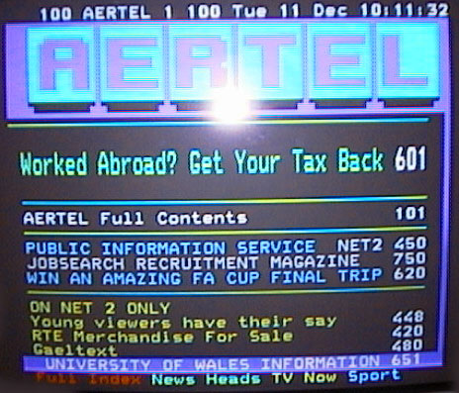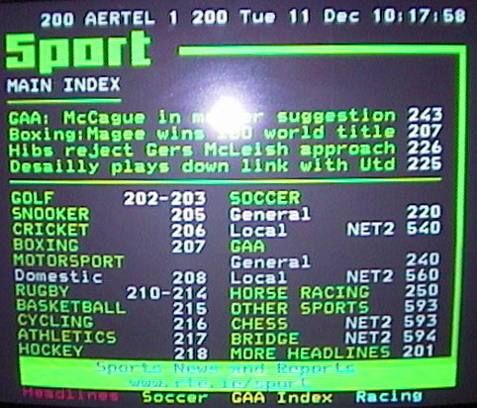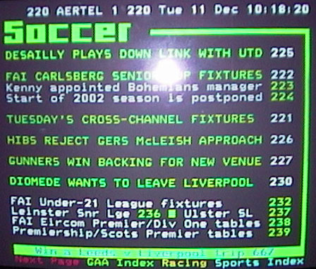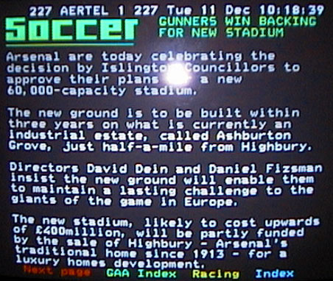
homepage – 100 : sport index – 200 : soccer index – 220 : soccer story - 227

13. Appendix 2: Aertel screenshots
Note on the screenshots: We originally planned to take still images from the video recording. However, the stills were of poor quality due to reflections between the television and camcorder. Because of this we have taken still images of the same pages on a later date, which are of better quality. The bright white spot seen in all images is the flash from the camera. We had to use a flash, as the images were too dark without one.

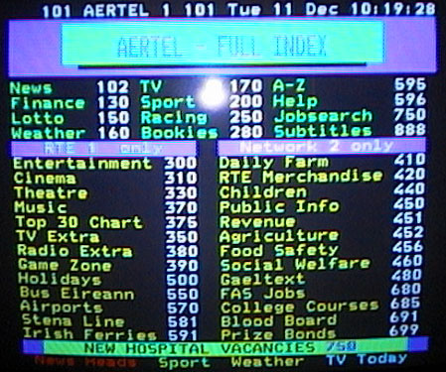
Image 1 Image 2

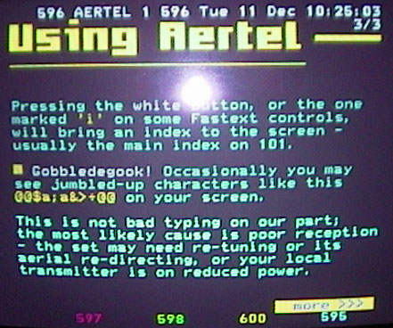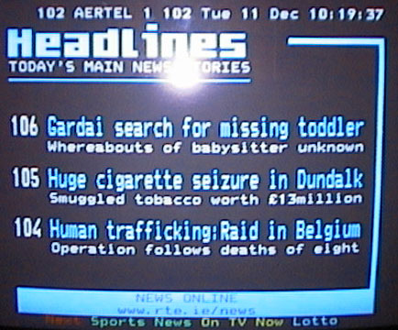
Image 3 Image 4

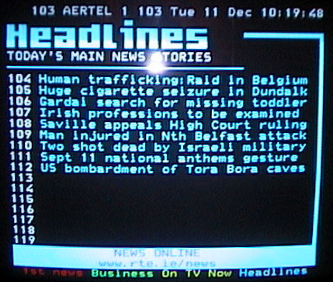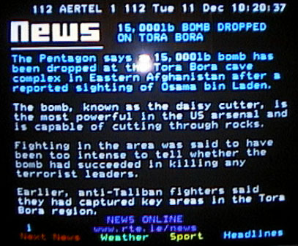
Image 5 Image 6

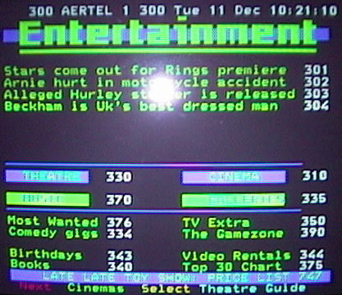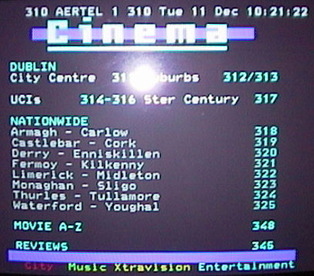
Image 7 Image 8

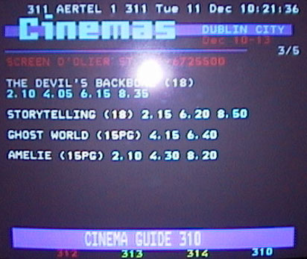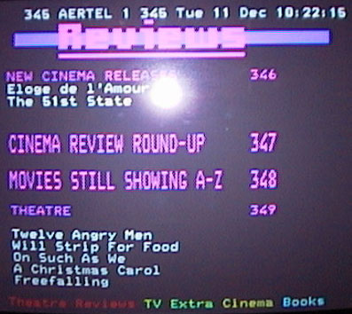
Image 9 Image 10

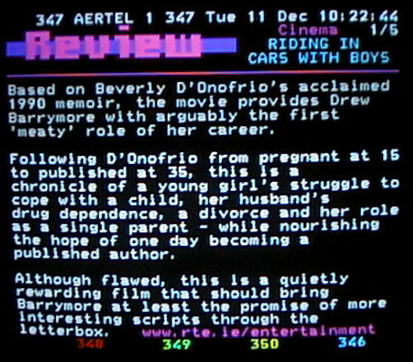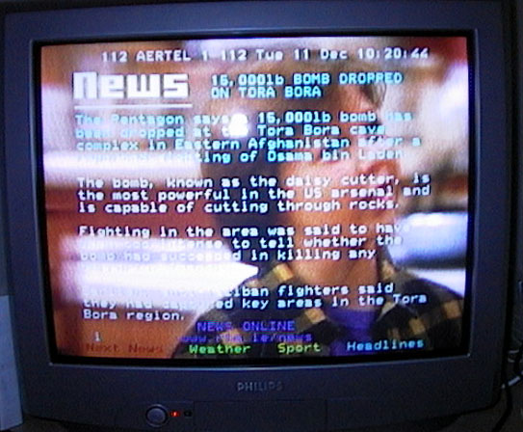
Image 11 Image 12

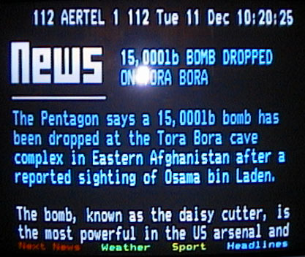
Image 13 Image 14

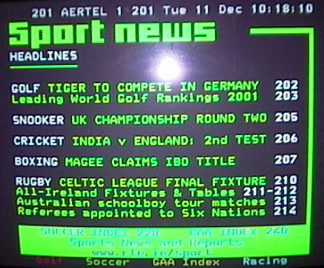
Image 15 Image 16

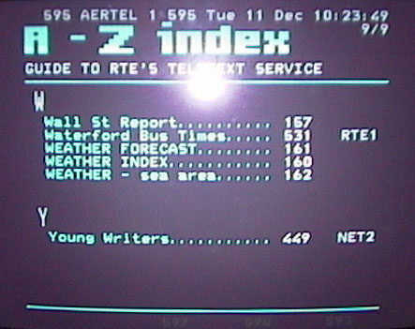
Image 17 Image 18

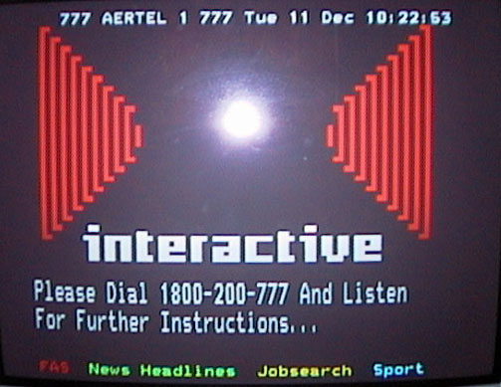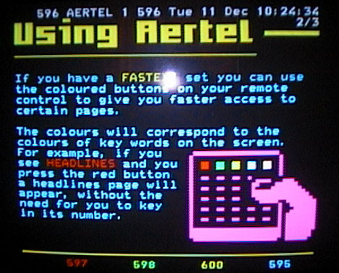
Image 19 Image 20

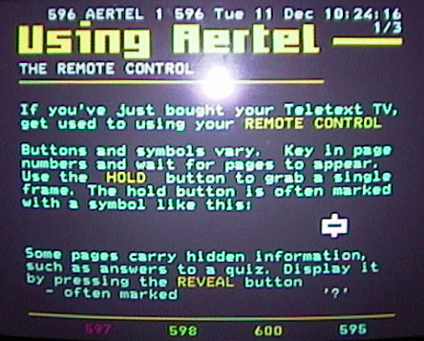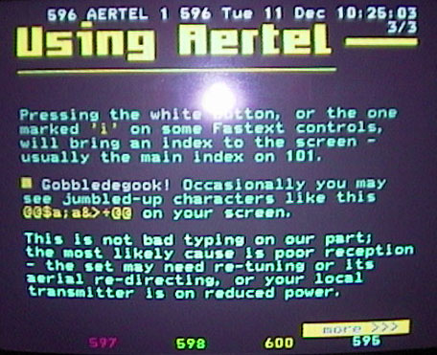
Image 21 Image 22

14. Appendix 3: Proposed structural solution

Basic Information: 100 – 109

Homepage: 100
Full Index: 101
Help Index: 102
Help pages: 103 – 109

News: 110 – 139

News index: 110
Irish news: 111 – 119
World news: 120 – 129
Weather: 130 – 135
National Lottery: 136 – 139

Business + Finance: 140 – 169

Finance Index: 140
Business news: 141 – 149
Financial Data: 150 – 159
Irish shares: 151
Dublin market: 152
Exchange rates: 153
Euro rates: 154
FTSE index: 155
CAC & DAX: 156
Hang Seng: 157
Nikkei: 157
Wall Street: 157
FTSE 100 Shares: 158
Banking: 160 – 169
Banking index: 160
AIB: 161 – 164
BOI: 165 – 168
Gov Savings Scheme: 169

Sport: 200 – 259

Sport index: 200
Sport headlines: 201
Golf: 202 – 203
Snooker: 204 – 205
Yachting: 206
Motorsport: 207 – 209
Rugby: 210 – 213
Basketball: 215
Cycling: 216
Athletics: 217
Hockey: 218
Chess + Bridge: 219
Soccer: 220 – 239
GAA: 240 – 249
Horse Racing: 250 – 259

Betting + Bookmakers: 260 – 299

Entertainment: 300 – 399

Entertainment index: 300
Entertainment news: 301 – 309
Cinema index: 310
Cinema listings
Dublin city centre: 311
Dublin suburbs: 312
Cork: 313
Galway: 314
Belfast: 315
Limerick: 316
Rest of Leinster: 317
Rest of Munster: 318
Rest of Ulster: 319
Rest of Connaught: 320

Current Film reviews
New releases: 321
Still showing: 322

Theatre index: 340
Books index: 350
Music index: 360
Comedy index: 370
Galleries/Museums: 380

TV and Radio: 400 – 499

TV: 400 – 199

TV index: 401
RTE 1 today: 402
Network 2 today: 403
BBC 1 today: 404
BBC 2 today: 405
ITV today: 406
Channel 4 today: 407
TG4 today: 408
TV3 today: 409
SKY today: 410
RTE 1 tomorrow: 411
Network 2 tomorrow: 412
BBC 1 tomorrow: 413
BBC 2 tomorrow: 414
ITV tomorrow: 415
Channel 4 tomorrow: 416
TG4 tomorrow: 417
TV3 tomorrow: 418
SKY tomorrow: 419

What’s on now: 420
TV films list: 421
TV films previews: 422
Soapwatch: 423
Program details: 425 – 439
Program details index: 425

Radio index: 450
Radio 1 today: 451
2FM today: 452
FM3 today: 453
RTE Radio Cork today: 454
R na G today: 455
Radio features: 356 – 469

Travel: 500 – 599

Travel index: 500
Bus 510 – 524
Full Index 501
Bus News 502 - 509
From ‘A’ 510
From ‘B’ 511
From ‘C’ 512
From ‘D’ 513
From ‘E-F’ 514
From ‘G-H’ 515
From ‘I-K’ 516
From ‘L-M’ 517
From ‘N-O’ 518
From ‘P-Q’ 519
From ‘R-S’ 520
From ‘T-U’ 521
From ‘V-Z’ 522

Train 525 – 539
Air 540 – 554
Sea 555 – 569
Holidays 570 – 599

Agriculture 600 – 649

Social Welfare 650 – 699

Employment 700 – 749

Education 750 – 799

Other Topics 800 – 999

Subtitles 888

Appendix 4: Proposed Graphic solution
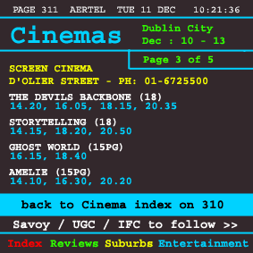
Current Cinema page Proposed new Cinema page

The proposed new cinema page has a few design changes from the current cinema page as a result of our evaluation of the Aertel system and our findings on the design errors within. First of all there are new natural mappings. For example, the fastext links are relevant to the page being viewed. The words used clearly tell the user where that link will take them as opposed to just meaningless numbers. It also clearly states that the current page being viewed is page 3 of 5 and gives the names of the other cinemas which lie on following pages. It also clearly tells the user that the cinema index is located on page 310, avoiding confusion regarding where they have just come from. It is not technologically possible to have a history or ‘back’ button within the Aertel system so we feel that our new design is a good alternative. It would have been interesting for us to apply our new prototype and see how well it works (using the Thinking-Aloud method) but unfortunately the resources needed to undertake such a test are beyond the parameters of this study.

Appendix 5: The future of teletext

To those fascinated by the constant upping the stakes of bandwidth and rich media content on the Internet the blocky, seven colour ASCII display and numeric interface of teletext by comparison may seem laughably archaic. Yet to dismiss it as a technological relic just yet would be jumping the gun. Presently there are half a million televisions with teletext in Ireland, and Aertel provides its users with constantly updated information on a wide variety of subjects, from local and international news to sports results and public transport timetables at the push of a button. Also the fact that RTE’s proposed terrestrial digital television service has been put on hold for the next ten years would suggest that the audience for Aertel’s present incarnation is secure for the time been.

The emergence of the World Wide Web might seem like a threat to teletext, instead many broadcasters worldwide are using the web as an additional system to broadcast their teletext content. RTE Online provides a live feed of Aertel’s information on their website. Aertel is brought to the web by using a piece of software by Intelfax that automatically converts Aertel’s pages into HTML and converts the 3 digit page numbers into hyperlinks to the corresponding page. The A to Z index is provided as a side menu with hotlinks, retaining Aertel’s information organization but eliminating the wait normally associated with teletext. One disadvantage of this system is the user must be aware to hit browser reload when returning to a previously visited page or else an outdated page will be displayed. It is interesting to observe that in making the transition to the web teletext not only gains from the web browsers point and click ease of use but also inherits this fault in caching to which the solution is not immediately obvious to many users.

The next step for teletext is a hybrid of its existing easy access to information coupled with the page browsing mentality and visual sophistication of the World Wide Web. As mentioned before he advent of digital teletext for RTE looks unlikely for several years yet but in the UK Teletext (the company) has unleashed it’s next generation teletext information service for digital television viewers.

While the conventions of 3 digit page numbers and the four coloured ‘fastext’ buttons have survived the transition from the systems analogue ancestor, technically this is where the similarities between digital and analogue teletext end. Digital teletext is delivered in its own data stream of 1s and 0s instead of ‘piggy backing’ a station signal and as a result has a channel of it’s own. Also, in addition to numeric page selection and the fastext buttons, digital teletext content can also be browsed through by a set of four direction buttons and an ‘enter’ key on the digital handset.

Visually digital teletext is a quantum leap from it’s pixilated 1970s predecessor. The graphic quality of digital teletext easily rivals the best your Internet browser can deliver, with the ability to display full colour, high definition images. Gone are the previously imposed restrictions on type usage forced by the limited resolution and single font, allowing for a much more varied and aesthetically pleasing layouts without compromising functionality.

User feedback will be available too, the viewer capable of delivering feedback, for instance to participate in a poll. A modem inside the set top box is used to send the data back to the service provider where it is processed and the results displayed on teletext. Beyond simple forms, with the addition of a full keyboard digital teletext can provide a gateway to the services of the Internet without the usual fear factor involved for the techno phobic.

Digital teletext is a natural step in the convergence of information services into a singular ‘box’ in the corner of the living room. As stated by Graham Lovelace of Teletext Ltd “Ultimately, services like Teletext could end up providing the mass-market gateway to the Web. In fact, Digital Teletext might be the Web's vital missing ingredient, and a combination of Teletext and the Web could be a marriage made in heaven.” (source: mb21 – Teletext Then and Now http://teletext.mb21.co.uk/)

